Boughton Parish Council
Consultation on traffic calming proposals
Briefing Note

The Parish Council is consulting residents on the proposal of West Northamptonshire Council (WNC) to apply a 20mph speed limit as a means of ameliorating the impact of traffic from the new North West Relief Road on Boughton Village. Details of the proposal can be seen in full in the document on this web site “NNWRR – BOUGHTON & MOULTON TRAFFIC CALMING MEASURES”. [See also notes on the proposals below.]

Residents’ views are invited

- By email to the clerk@boughtonparishcouncil.co.uk. Please be sure to include your name and address.

- By coming to a Parish Meeting in the Village Hall at 7pm on Monday 19th May 2025 where your view can be recorded

In advance of the meeting this note explains the background. The parish council is also seeking to have graphics of the proposals on display before that meeting.

The North-West Relief Road is the new road now under construction which will link the A428 (Harlestone Road) with the A5199 (Welford Road). It is planned to open in early 2026. This affects Boughton Parish as it is expected to route additional traffic to the Harborough Road roundabout. From there, whilst the substantial traffic destined for Moulton Park is encouraged to use the design route via Harborough Road and Holly Lodge Drive, an increasing number is expected to rat run through the village.

Expert advice given to the Parish Council and modelling conducted by WNC confirm that absent any scheme applied to the village morning peak hour traffic eastbound and afternoon traffic westbound will increase significantly – in the order of 40%. The question is what is to be done?

The issue has troubled members of the Parish Council for many years. The timeline is worth reviewing:

2020
Modelling forecast that in 2031 am peak hour flow through the village would increase from 1007 to 1427 vehicle movements. Supporting the planning application for the new road a mitigation scheme is proposed comprising a new pinch point in Vyse Road and extending the one in Moulton Lane. That was accepted as being inadequate but no suitable alternative was found. The solution to enable the road to be built was to put back the problem by the application of a planning condition:

Condition 25: “Prior to the new road opening the applicant shall consult with Boughton Parish Council to agree the extent and detail of a scheme of measures for ameliorating the impact of traffic from the permitted development on Boughton village. The scheme as may be agreed shall be submitted to the Country Planning Authority and implemented in full prior to the new road opening.”

2021
The Council began discussions with WNC officers.

2022
We set up a task and finish group comprising residents from each street in the village which meets twice with the WNC officer. All manor of one way and other schemes were discussed. A 20mph speed limit was investigated and rejected by the speed panel of WNC. Closure of the road running along the west side of Boughton Green so as to prevent through access to Moulton Park was examined in detail but the modelling predicted that an increase in Moulton Lane traffic was caused so that was dropped.

2023
WNC asked for our support in the modelling of Moulton Lane closure. We agreed that that should be an option. It emerged in December as the Preferred Option of WNC.

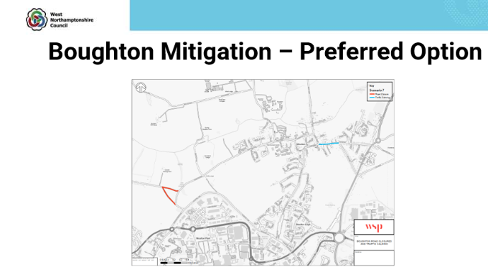

2024
As the Preferred Option became known it attracted adverse comment within WNC and further work was done. A new scheme involving an area subject to a 20mph speed limit came forward which is now the preference of WNC as shown in WNC’s presentation document now published.

Modelling in support of the scheme as a means of ameliorating the effect of the new road shows that in 2031 the volume of through traffic will be reduced to below the current level (ie below the 1007 figure mentioned above). The Parish Council is sceptical about that assessment but we have to accept that it is the result of computer modelling.

The view of the Parish Council is:

- Moulton Lane closure will dramatically resolve the traffic problem in the village but may cause a degree of inconvenience

- Whilst a lower speed limit will be of benefit we have little confidence that it will have much impact on traffic volume, dependant on driver routing behaviour

Moulton Lane closure is currently not offered by the district council. But it is an effective remedy, the preferred option in 2023, and the Parish Council is minded to press for it if it is supported by parishioners. If not, we will continue to work with the district council to implement as robust 20mph area as possible.

Notes on the proposals.

- A 20mph limit is proposed, with no physical measures inside the limit area, together with an additional pinch point at the east end of Moulton Lane

- A driver of the proposal seems to be the modelling identified that a 20mph speed limit would produce dramatic reductions of traffic, said to be
  - Eastbound traffic in the morning peak hour of -35% in Vyse Road and -51% in Mouton Lane.
  - Westbound traffic in the evening peak of -47% Vyse Road and -72% Moulton Lane

- The Parish Council asked for a speed limit to be imposed immediately to test the traffic reductions and for the limit to apply to the same area as is currently covered by the 30mph limit; both requests were declined

- In discussions with parishioners forms of road closure were discussed which are identified as DS12 (closure of the west section of road along Boughton Green) and DS13 (the “preferred option” of Moulton Lane closure mentioned above). The WNC view is that they “do not significantly reduce the flows through Boughton”.

- The parish council has instructed Stirling Maynard to advise on the effect of the proposal; their report will be published on the web site when received

Views are invited by email to the clerk or by attendance at the Parish Meeting at which officers from the district council will present and answer question on their proposal and after which a poll will be taken.

